
KING EDWARD
GAS OVEN (GOLPG1)

INSTALLATION, OPERATING AND SERVICING INSTRUCTIONS
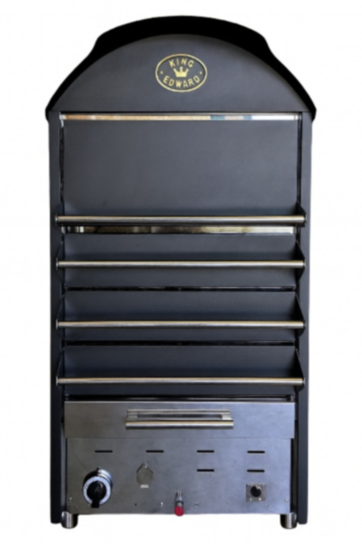
Date Purchased:
Model Number:
Serial Number:
Dealer:

CONTENTS

INSTALLATION AND COMMISSIONING 3
IMPORTANT: 3
RISK ASSESSMENT 3
INSTALLATION 4
INSTALLATION IN VEHICLES/TRAILERS – ADDITIONAL REQUIREMENTS 4
GAS SUPPLY AND CONNECTION 5
TECHNICAL DATA 5
USING THIS APPLIANCE 6
COOKING 7
CLEANING 8
THINGS TO REMEMBER 8
SERVICE INFORMATION 9
SPARE PARTS LIST 9
DISPOSAL AND RECYCLING 10
FAULT FINDING & TROUBLE-SHOOTING 10

INSTALLATION AND COMMISSIONING
This appliance is manufactured and approved for use within catering trailers used outdoors.

IMPORTANT:
This appliance must be installed and serviced by a competent, qualified person as stipulated by the Gas Safety (Installation & Use) Regulations and in accordance with national and local regulations in force for the country of installation.
When installing the appliance, please verify that the current state adjustment of the appliance is compatible with the local distribution conditions, nature of gas and pressure; and if applicable, the local electrical supply conditions are compatible with the electrical data given on the data plate.

Particular attention should be paid to:
- Gas Safety (Installations & Use) Regulations
- Health & Safety at Work Act
- Local & National Building Regulations
- Fire Precautions Act.
Detailed recommendations are contained in Institution of Gas Engineers published documents IGE/UP1, IGE/UP/2, BS6173 and BS5440.
This appliance has been UKCA and UKNI marked based on compliance with the Gas Appliances (EU Regulation) Regulation/Product Safety and Metrology for the gas types and pressures as stated on the data plate.

RISK ASSESSMENT
To ensure the health and safety of your staff and customers, you must identify and manage any potential risks associated with the installation and use of this gas oven. Consider both the product itself and the surrounding environment within your commercial kitchen. Identify potential hazards and implement reasonable control measures to reduce risk.
Do not connect the appliance to networks containing gases such as carbon monoxide or other toxic components.
For further guidance on conducting a risk assessment, please refer to the Health and Safety Executive (HSE) website: www.hse.gov.uk

INSTALLATION
This appliance must be installed on a level, fireproof surface. There must be a clear space of 150mm between the rear and sides of the unit and any combustible wall or material.
Use the factory-supplied fitting brackets to secure the appliance into place. The installer must pay attention to ensuring there is sufficient airflow around the appliance and that the air combustion admission is not disturbed or obstructed.
Adequate ventilation around the appliance must be provided to allow for complete gas combustion and to allow for easy removal of combustion products which may be harmful to health.
The gas supply hose must be leak-free, tested for gas tightness, and compliant with national regulations. It should be inspected regularly and replaced as needed.
If a flexible pipe is used as the final connection to the oven, it must be suitable for LPG and no longer than 2m. It should be routed under the counter supporting the oven.

INSTALLATION IN VEHICLES/TRAILERS – ADDITIONAL REQUIREMENTS
When installing this appliance into a catering vehicle or trailer, the installation must also comply with all relevant regulations and standards for LPG appliances in mobile catering, including but not limited to:
- UKLPG Code of Practice 24 Part 3 – “Use of LPG for Catering in Commercial Vehicles and Trailers” (covers ventilation, gas storage, pipework, and appliance location)
- BS EN 1949 – “Specification for the installation of LPG systems in leisure accommodation vehicles and in other road vehicles”
Key points to include:
- Adequate permanent ventilation must be provided in the vehicle to ensure complete combustion and safe dispersal of combustion products.
- Appliance must be securely fixed to prevent movement during transport.
- All gas pipework must be rigid where possible and comply with BS EN 1057 (copper tube) or equivalent.
- Flexible hoses (if used) must be BS EN 14800 or equivalent, suitable for LPG, and kept as short as possible.
- LPG cylinders must be stored in a ventilated compartment, sealed from the interior, with access only from the outside of the vehicle.
- An emergency isolation valve must be fitted close to the appliance.
- All installations must be tested for gas tightness and issued with a valid Gas Safety Certificate by a Gas Safe engineer qualified for LPG in commercial catering vehicles.

GAS SUPPLY AND CONNECTION
This appliance must only be used with Propane Gas G31 with a suitable 37 mbar regulator.
Oven Burners are fitted with a fixed injector and set aeration apertures. No adjustment possible.
Unless otherwise stated, the instructions indicate that the parts protected by the manufacturer or it’s Authorised Representatives shall not be adjusted by the installer.

TECHNICAL DATA

Unpacked weight | 145kg
Packed weight | 195kg
Dimensions WDH (mm) | 700 x 720 x 1350
kW Propane Full Rate | 8.75kW
BTU Propane Full Rate | 29,855
Gas Consumption Full Rate | 0.625 kg/h
kW Propane Minimum Rate | 3.0kW
BTU Propane Minimum Rate | 10,236
Input Gas Connection | Male 3/4" BSP
Gas Pressure | 37mb
NAT Gas Conversion | No

USING THIS APPLIANCE
Prior to using the appliance for the first time, make sure that ALL packing material has been removed.
Ensure that the appliance is sited and fixed in accordance with our installation instructions.
This appliance is intended to be used for commercial use to bake jacket potatoes. All users should be trained in how to light, clean, shut down and safely operate it. Oven gloves or gauntlets must be used at all times and all operators should be made aware of the risk to themselves due to the high temperature of the outside casing and door/drawers.
Opening the oven drawers/doors will expose the operator to high temperatures as the hot air/steam rapidly escapes.
Never leave the oven unsupervised and always turn off after use.
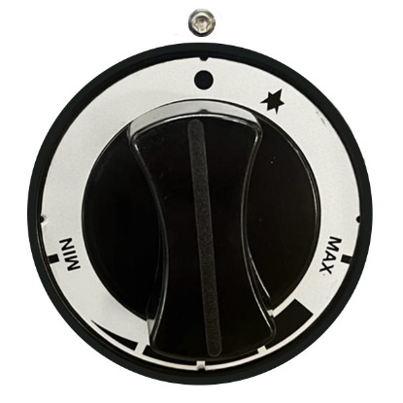
Before lighting the appliance, make sure the gas regulator and any in-line stop cocks are in the open position.

- Take out the lower and middle drawer.

- Make sure that the thermostat control knob is in the OFF position. (drg 1)
Diagram 1
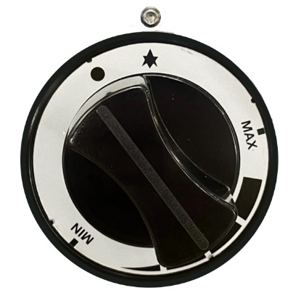
- Push the control knob in until it stops and turn it anticlockwise to the Pilot position. (drg 2)

- While the control knob is pressed in at the pilot position, press the piezo button to ignite the pilot. (drg 3) Keep the control knob pressed in for a further 15 seconds.

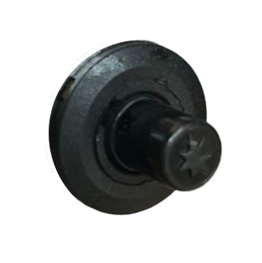
- Release the control knob, the pilot should light. If it does not repeat the process.
Diagram 2

- With the control knob released and the pilot lit, turn the control knob to the “max” position. (drg 4) The main burner should now light.
Diagram 3
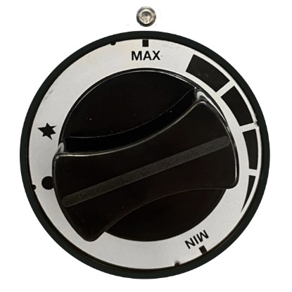
- You can now rotate the control knob to the desired setting. Maximum setting is around 300°c (drg 4)

- Observe the flame integrity by looking through the baffle in the bottom of the oven for approximately 30-45 seconds.
Diagram 4

- To turn off the appliance - Turn the control knob clockwise to the ‘Max’ position, press it in, and continue turning to the ‘Off’ position. (You can also leave the pilot light on if you only turn it to the pilot position). (drg 4)

COOKING
With the oven set to its maximum temperature, allow it to run for a minimum of 20 minutes to fully heat and flue.
The oven must remain empty during this initial heat-up period to ensure the flue reaches sufficient temperature for even heating throughout the oven.
Once preheated, load the potatoes into the trays, starting from the top drawer and working downwards. Ensure there are air gaps between the potatoes to allow proper air circulation.
Check the potatoes after 30 minutes, 1 hour, and then at 5–10 minute intervals thereafter. Turn and adjust the potatoes as needed until they are evenly cooked and tender throughout.
Cooking times will vary depending on the size and quantity of the potatoes.

CLEANING
Failure to clean may result in unsafe operation or invalidated warranty.
- Always allow the appliance to cool completely before cleaning.
- Do not submerge this appliance in water or use a water jet or steam cleaner to clean it.
- Do not use any kind of abrasive or corrosive cleaning materials on the painted surfaces.
- Stainless steel surfaces (oven interiors, drawer inners) can be cleaned using a proprietary stainless steel cleaner.
- The baskets can be removed and cleaned in warm soapy water.
- After use, remove any food debris from around the burner and assembly.
- Daily cleaning after use and a weekly deep clean are advised.

THINGS TO REMEMBER
Avoid opening the drawers/doors unnecessarily as this will increase heat loss and cooking times.
Do not line the baskets/trays with foil or baking trays as this will impede airflow around the oven cavity.
Always use an oven glove and take care when handing hot potatoes.

SERVICE INFORMATION
This appliance is designed and approved for use in mobile catering units only. As installation may be affected when the unit is moved or repositioned, the manufacturer offers a parts-only warranty valid for one year from the date of purchase. Labour, call-out charges, and servicing are not included. Your statutory rights are not affected.
Installation, servicing, and all gas-related work must be carried out by a Gas Safe registered engineer. You may be required to provide a valid Gas Safety installation certificate confirming that the appliance has been installed correctly.
The manufacturer accepts no liability for incidental or consequential damages arising from the use or installation of this appliance.

SPARE PARTS LIST
Spares can be ordered directly from King Edward – oven@kingedward.co.uk 01885489200
Part Number | Description
BB1 | Burner Body
BB1C | Burner Cap
61160 | Injector (LPG Gas)
61F | Injector Fitting 90°
P3W | Pilot 3 Way
PE1 | Electrode (Inclined)
TC1 | Thermocouple
PT1 | Pilot Tube
BO 6M | Brass Olive For Pilot
P1B | Piezo Ignitor
PIL | Piezo Lead
T/ST1J | Welding Ipon Joint
TS | Control Knob
GOCK1 | Control Knob Sticker
BSP | Burner Supply Pipe 10 dia Copper
6TSSP | Iron Gas Supply Pipe
6TS1 | Gas Thermostat

DISPOSAL AND RECYCLING
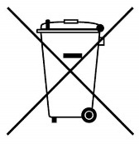

The packaging used for this product can all be recycled. Please dispose of it responsibly and with consideration for the environment.
At the end of its life, dispose of the appliance and its components responsibly, through a licensed waste handler in accordance with WEEE regulations. WEEE Directive Registration WEE/

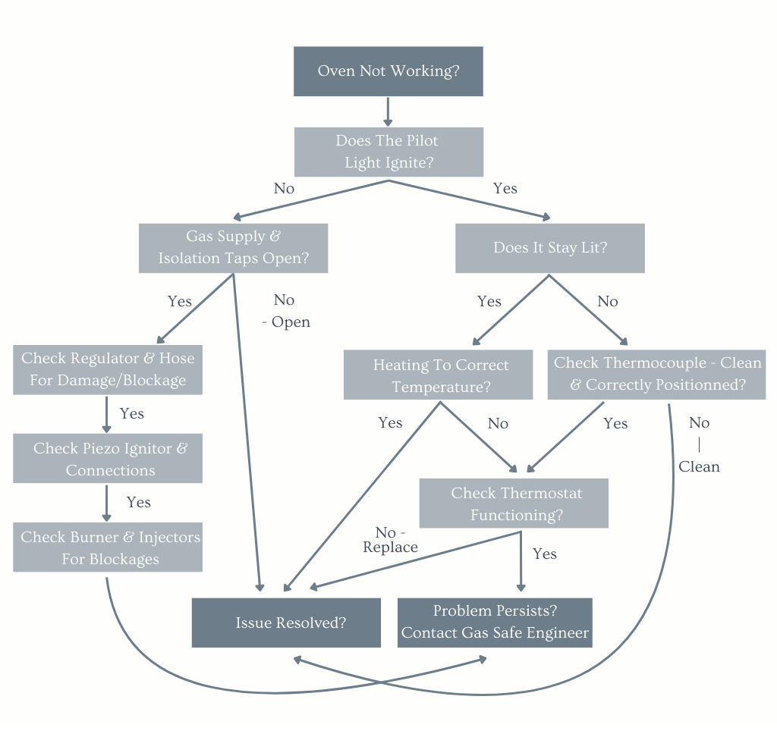
FAULT FINDING & TROUBLE-SHOOTING

